**-README FILE -**

**HMO DATABASE MANAGEMENT**

General description:

This code defines a class named **‘MyDatabase’** which provides methods to interact with a MySQL database. The class establishes a connection to the database in its constructor and defines methods for inserting and fetching data to and from tables named **‘personal_info’**, **‘vaccines_info’**, and **‘covid_infections’**. The goal of the program is to help the HMO manage all the data from the covid-19 crisis. Such as vaccinations and infections of the HMO members. The program includes an API that is exposed to the client side. The program assumes each member of the HMO can get infected once.

Basic usage description:

The program includes various methods. I will go over them.  
The ‘insertMemberPersonalInfo’ method inserts a new record into the ‘personal_info’ table. It takes a ‘Member’ object as a parameter and sets the appropriate values in a prepared statement and into the database.

The `insertVaccineInfo` method inserts a new record into the `vaccines_info` table. It takes a `CovidVaccine` object as a parameter and first checks whether a member with the given ID exists in the `personal_info` table. If so, it checks the number of vaccines already recorded for the member and inserts a new record if the member has received fewer than four vaccines.

The `insertCovidInfection` method inserts a new record into the `covid_infections` table. It takes a `CovidInfection` object as a parameter and first checks whether a member with the given ID exists in the `personal_info` table. If so, it checks whether a record for the member already exists in the `covid_infections` table and inserts a new record if it does not.

The `getVaccinessList` method queries the `covid_vaccines` table and returns an ArrayList of `CovidVaccine` objects, each representing a record in the table. A call to the method with a looping ToString will give this result in the terminal:

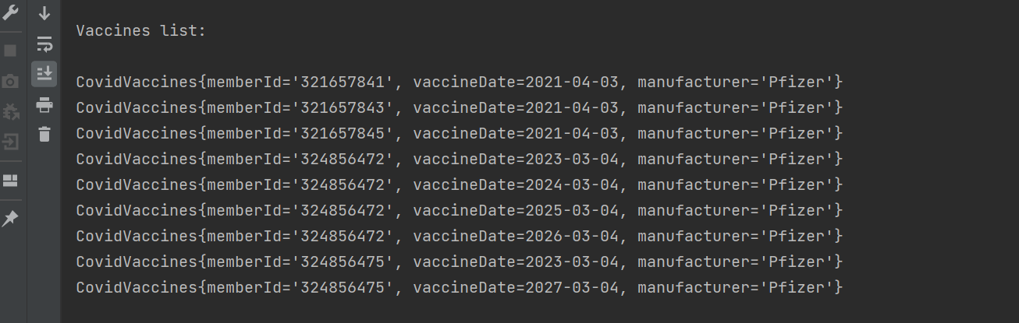

The `getInfectionsList` and `getMembersList` work in the same way.